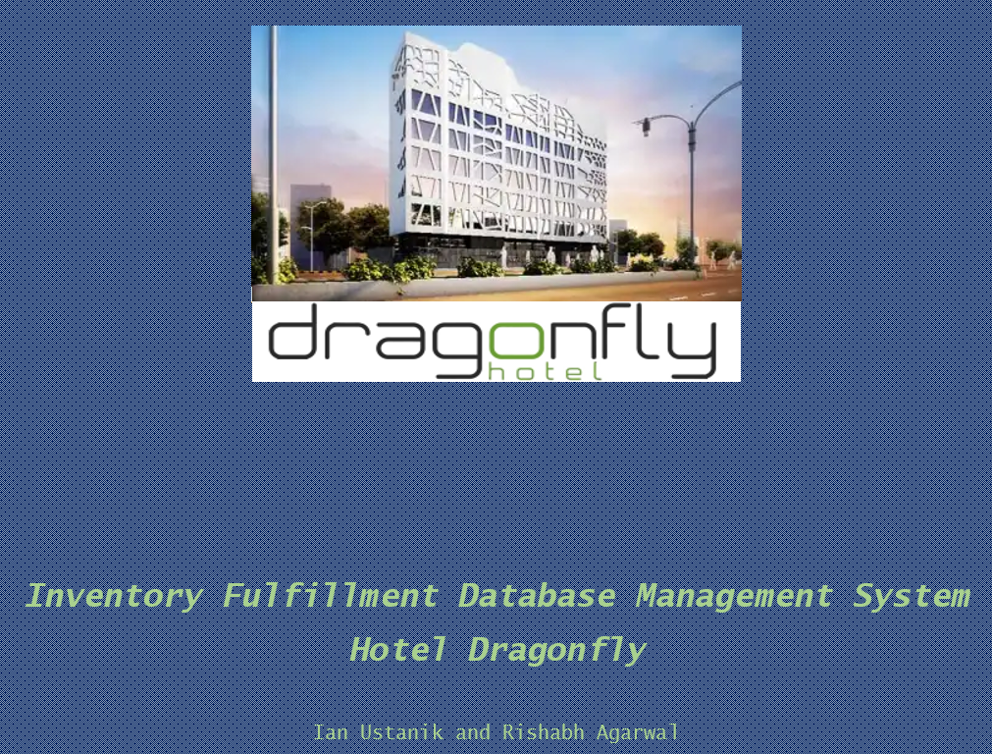

**BUG REPORT/LESSONS LEARNED**

**Project Bug Report/Lessons Learned:**

**Bugs and Solutions**

1. The first bug that we identified was a lack of a transaction for the OrderLine table. This was an issue because records could be entered into the Purchase table without one being made for the OrderLine. This would lead to uneven tables that were inconsistent across the database. Even worse, this would jeopardize the integrity of the data. The solution that we came to for this bug was creating a transaction. A transaction allows the user to execute a set of SQL operations to ensure that the database never contains the result of partial operations. This would ensure that new records entered into tables that shared attributes with OrderLine would also update the OrderLine table as well.

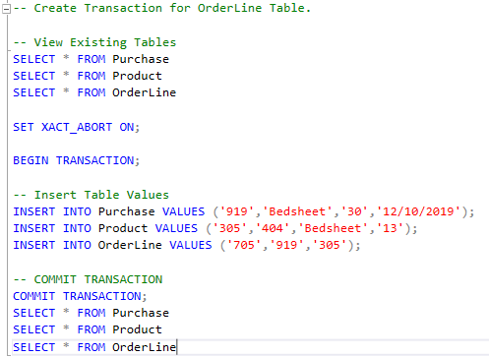

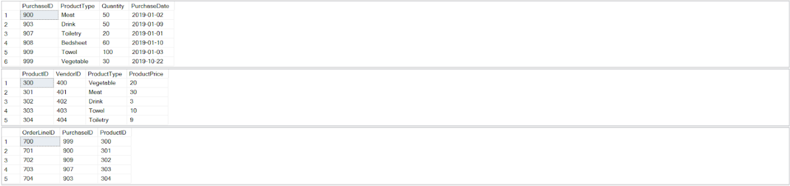

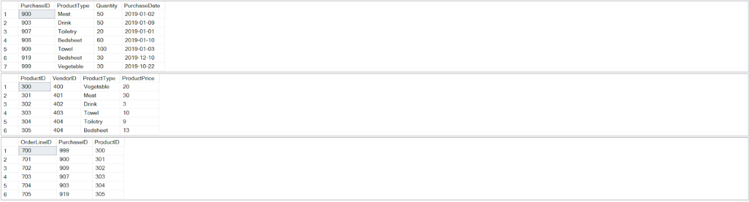

1. The second bug which we had identified was the lack of a combo box in the product type section of the purchase and product forms. Since for the project purposes we had classified the different products required into vegetables, meat, drink, toiletries, bedsheet and towel units but in actual there would be many more than these. Any error while filling out the product type section in these forms can lead to inconsistencies. Using a combo box in these sections can eliminate the possibility of making a mistake.

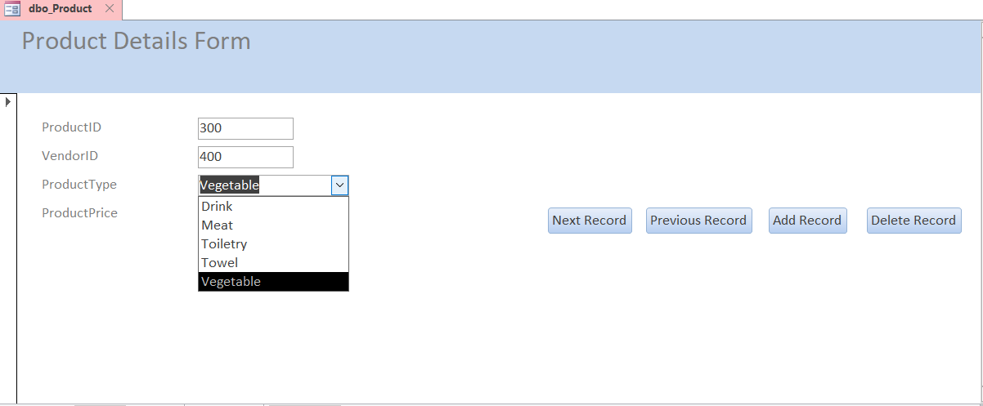

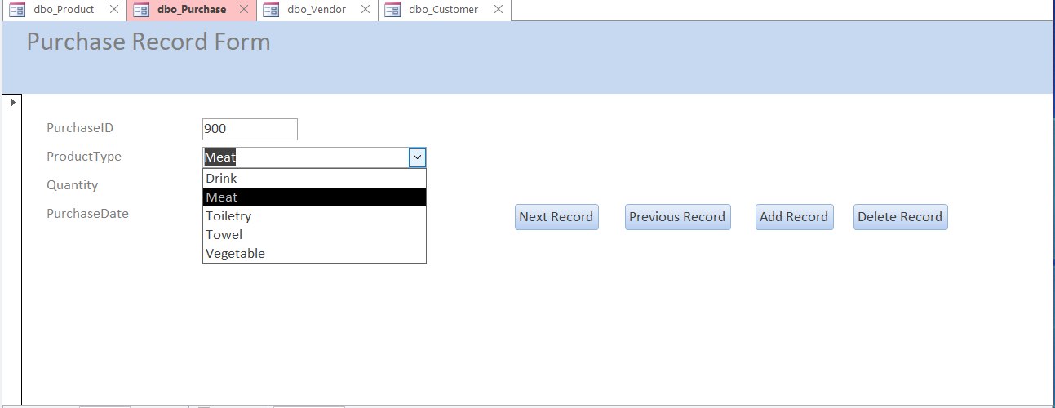

1. The third bug which we had identified was the lack of a login system. With a login system, we can ensure that only the authorized users can access the database system.

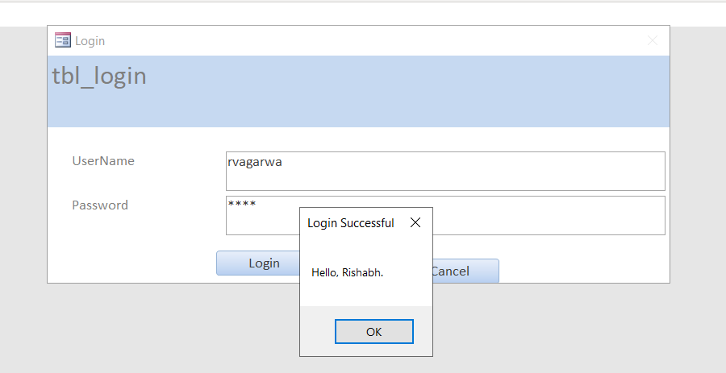

**Lessons Learned**

1. In my opinion, one of the most valuable lessons that we learned for the project consisted of the planning stage of the database implementation. As we found out later in the project, the planning stage is perhaps the most important. We appreciated how the project was realistic in that we had to figure out business requirements and identify the scope of the database system through interaction with the client. Through interviews and communication back and forth, we were able to meet the needs of the stakeholders from Hotel Dragonfly.
2. Another lesson learned was the use of SQL. Over the course of this project we learned a great deal about using the common language for data definition, data manipulation, and data control. Data definition language was used for the physical design and maintenance of the database. Data manipulation language was used for implementation of the database. Data control language was used for both database implementation and maintenance. We also are now familiar with using MySQL and are comfortable with using it for further projects.
3. Finally, an important lesson learned was the various uses of data modeling. The entity relationship model was paramount in our database design, and it made it easier to visualize our data flow when we were programming the database. The hierarchical data model helped us distinguish between strong and weak entities. Finally, the enhanced ERD allowed us to identify and supertype and subtype relationships for our project. We found this last model not necessary to use for our project however.